

BIRLA INSTITUTE OF TECHNOLOGY & SCIENCE, PILANI
Work Integrated Learning Programmes Division

Post Graduate Program

in

Artificial Intelligence and Machine Learning

Demand Forecasting for Retail Inventory Optimization

CAPSTONE PROJECT

Submitted in partial fulfilment of the requirements of the

Post Graduate Certification Program
in
Artificial Intelligence and Machine Learning

By
SAJAL DEBNATH (2024aiml521)
ANTONY SUDHARSAN ( )
KRITI SHARMA ( )
AJAY ( )

Under the supervision of

PROF. SUDARSHAN S. DESHMUKH

Project work carried out at

BIRLA INSTITUTE OF TECHNOLOGY AND SCIENCE
Pilani (Rajasthan) INDIA
(April 2026)

PGCP AIML_Oct_2024_C6 CAPSTONE PROJECT

Demand Forecasting for Retail Inventory Optimization

Submitted in partial fulfilment of the requirements of the

PGCP - Artificial Intelligence and Machine Learning

By
SAJAL DEBNATH (2024aiml521)
ANTONY SUDHARSAN ( )
KRITI SHARMA ( )
AJAY ( )

Under the supervision of

PROF. SUDARSHAN S. DESHMUKH

Project work carried out at

BIRLA INSTITUTE OF TECHNOLOGY AND SCIENCE
PILANI (RAJASTHAN)
(April 2026)

BIRLA INSTITUTE OF TECHNOLOGY AND SCIENCE, PILANI

CERTIFICATE

This is to certify that the Capstone Project entitled Digital Twin for Indian Rural Health Care Infrastructure submitted by

SAJAL DEBNATH (2024aiml521)
ANTONY SUDHARSAN ( )
KRITI SHARMA ( )
AJAY ( )

in partial fulfilment of the requirements of AIML Oct 2024_PCAMZC321 Capstone Project, embodies the work done by him/her under my supervision.

Place : ______________ Signature of the Mentor

Date : _______________ Name : ________________

BIRLA INSTITUTE OF TECHNOLOGY & SCIENCE, PILANI
SECOND SEMESTER 2024-25

AIML Oct 2024_PCAMZC321 CAPSTONE PROJECT

Project Title : Demand Forecasting for Retail Inventory Optimization

Name of Mentor : PROF. SUDARSHAN S. DESHMUKH

Name of Student : SAJAL DEBNATH, ANTONY SUDHARSAN, KRITI SHARMA, AJAY

ID No. of Student : 2024AIML521, < >, < >, < >

Abstract

Retail inventory optimization is a multi-dimensional problem characterized by demand uncertainty, price elasticity, seasonal variability, and supply chain constraints. Traditional heuristic-based approaches often fail to capture the complex, non-linear relationships between these factors, leading to suboptimal stocking decisions. This project addresses the problem by designing a data-driven Retail Intelligence System that leverages machine learning for simultaneous stocking priority classification and sales forecasting.

The proposed system integrates heterogeneous data sources, including product attributes, pricing signals, promotional indicators, supply chain variables, environmental conditions, and digital engagement metrics. A comprehensive data preprocessing and feature engineering pipeline is developed to transform raw inputs into a structured representation suitable for modeling. Notably, a hybrid feature construction strategy is employed, combining numerical variables with contextual representations derived from categorical attributes through a templated encoding mechanism. This approach enables the model to capture both quantitative relationships and semantic context within the data.

Two primary predictive tasks are formulated:
- A multi-class classification problem for determining stocking priority levels (High, Medium, Low)
- A regression problem for estimating expected product demand (sales forecasting)

For the classification task, a hybrid Logistic Regression model is implemented, leveraging both engineered numerical features and contextual embeddings. For the regression task, supervised learning models are trained to capture demand patterns influenced by pricing, promotions, and external factors. Model performance is evaluated using standard metrics, including accuracy for classification and R² and RMSE for regression, demonstrating strong predictive capability and generalization.

In addition to baseline models, exploratory experiments with deep learning architectures and transformer-based approaches were conducted to assess their ability to model non-linear and high-dimensional interactions. While these models showed potential improvements in representational power, the hybrid approach was selected for deployment due to its balance between performance, interpretability, and computational efficiency.

The system is operationalized using a FastAPI-based microservice architecture, enabling scalable and low-latency inference. A web-based frontend interface is developed to facilitate user interaction, allowing for real-time prediction, parameter manipulation, and scenario simulation. This integration transforms the predictive models into a practical decision-support system for retail stakeholders.

From a business perspective, the system provides actionable insights into demand drivers, highlighting the influence of pricing strategies, marketing spend, and customer engagement on sales outcomes. It also identifies operational risks such as supplier delays and limited shelf life, enabling proactive mitigation strategies. The inclusion of simulation capabilities further enhances decision-making by allowing users to evaluate hypothetical scenarios and optimize inventory strategies accordingly.

In summary, this work demonstrates the effective application of machine learning in retail analytics through:
- A hybrid feature engineering framework integrating structured and contextual data
- Multi-task predictive modeling for classification and regression
- Deployment of scalable, real-time inference systems
- Translation of predictive outputs into actionable business insights

The proposed solution provides a robust and extensible foundation for intelligent retail decision systems and highlights the potential of AI-driven approaches in improving inventory efficiency, reducing operational risk, and enhancing overall business performance.

List of Symbols & Abbreviations

Abbreviation / Symbol | Full Form / Description
API | Application Programming Interface – used to expose model predictions and system functionalities via web services
ASGI | Asynchronous Server Gateway Interface – protocol used by Uvicorn to serve FastAPI applications
BERT | Bidirectional Encoder Representations from Transformers – deep learning model used for contextual text embeddings
BoW | Bag of Words – text representation method based on word frequency counts
CSV | Comma-Separated Values – standard format used for storing tabular datasets
DL | Deep Learning – neural-network-based modeling approach used for classification experiments
EDA | Exploratory Data Analysis – statistical and visual analysis used to understand dataset structure and relationships
F1 Score | Harmonic mean of precision and recall – used to evaluate classification performance
FastAPI | High-performance Python web framework used to deploy the retail intelligence system
IQR | Interquartile Range – statistical measure used for distribution spread and outlier detection
KNN | K-Nearest Neighbors – algorithm used for imputing missing values in preprocessing
MAE | Mean Absolute Error – average magnitude of prediction errors in regression
ML | Machine Learning – data-driven modeling techniques used for prediction and classification
PCA | Principal Component Analysis – dimensionality reduction technique used for latent structure analysis
RMSE | Root Mean Squared Error – measures standard deviation of prediction errors
R² | Coefficient of Determination – indicates proportion of variance explained by regression model
TF-IDF | Term Frequency–Inverse Document Frequency – weighted text representation method
UI | User Interface – frontend dashboard used for system demonstration
Uvicorn | ASGI server used to run FastAPI applications
RF | Random Forest – ensemble learning algorithm used for feature importance analysis
Ridge Regression | Regularized linear regression model used for demand prediction
Logistic Regression | Classification model used for stocking-priority prediction
Transformer | Deep learning architecture used for advanced text modeling (Hugging Face benchmark)
NLP | Natural Language Processing – techniques used for handling product text data
SKU | Stock Keeping Unit – unique identifier for retail products
TF | Term Frequency – frequency of a term in a document (used in TF-IDF)
Feature Engineering | Process of transforming raw data into meaningful model inputs
Target Leakage | Occurs when future or outcome-derived information is used in training models
Profit Density | Ratio of gross profit to shelf capacity – key business metric for prioritization
Fill Rate | Percentage of demand fulfilled from available stock – indicator of supply reliability
Shelf Life | Duration for which a product remains sellable before expiration
Supplier Delay | Time lag in product replenishment – operational risk factor
Footfall Index | Proxy measure for customer traffic in a retail store
Discount % | Percentage reduction in product price relative to base price
Lead Time | Time between placing and receiving inventory orders
Hybrid Model | Model combining structured numerical features with text representations
Scenario Simulation | Process of evaluating model outputs under different hypothetical business conditions
Recommendation Engine | System component that ranks products based on business objectives
Stocking Priority Class | Target variable categorizing items into Low, Medium, or High priority
Daily Units Sold | Regression target representing product demand per day

Table of Contents

1. Problem statement 17

1.1 Problem Description 17

1.2 Formal Problem Definition 17

1.3 Dataset Context 18

1.4 Scope of the System 18

2. Objectives 18

2.1 Primary objectives 18

2.2 Secondary objectives 19

3. Dataset Overview 19

The final project uses a structured retail dataset stored in `data/raw/master_retail_dataset_v2.csv`. The dataset contains 2,000 observations and 64 columns, combining product descriptors, pricing variables, demand signals, store context, external conditions, and operational inventory variables. 19

3.1 Dataset scope 19

The dataset contains both commercial and operational views of retail performance: 19

- product descriptors such as category, sub-category, product name, brand, and brand tier 20

- pricing and promotion variables such as base price, current price, competitor price, discount percentage, promotion type, and marketing spend 20

- customer and traffic proxies such as footfall, app traffic, website visits, loyalty usage, repeat purchase rate, and basket size 20

- operational variables such as shelf capacity, shelf life, supplier delay, stock on hand, fill rate, and safety stock 20

- temporal and contextual variables such as day of week, month, holiday status, weather, and festival indicators 20

This breadth makes the dataset suitable for both demand forecasting and inventory intelligence tasks 20

4. Previous Work in Retail Demand Forecasting and Inventory Optimization 20

4.1 Retail Demand Forecasting Models: 20

4.2 Machine Learning in Retail Analytics: 20

4.3 Deep Learning and Hybrid Approaches: 20

4.4 Inventory Optimization and Decision-Support Systems: 21

4.5 Research Gap: 21

5. Detailed Plan of Work 21

Table 1: Plan of Work 21

Week 21

Phase 21

Key Activities 21

Deliverables 21

Week 1 22

Data Acquisition & Preparation 22

- Load and validate dataset 22

- Handle missing values and encoding 22

- Normalize features 22

- Initial EDA and correlation analysis 22

- Identify targets 22

- Cleaned dataset 22

- EDA plots (distribution, correlation) 22

- Data preprocessing pipeline 22

Week 2 22

Exploratory Data Analysis 22

- Demand distribution analysis 22

- Feature correlation study 22

- Random Forest feature importance 22

- analysis 22

- Temporal & category insights 22

- EDA report with visualizations 22

- Feature importance charts 22

- Insights summary 22

Week 3 22

Feature Engineering & Baselines 22

- Numerical and temporal feature engineering 22

- Text feature creation (TF-IDF) 22

- Train baseline regression models 22

- Evaluate metrics 22

- Identify leakage issues 22

- Feature-engineered dataset 22

- Baseline model results 22

- Leakage analysis report 22

Week 4 22

Advanced Modelling 22

- Create stocking priority target 22

- Train classification models (logistic, hybrid) 22

- Implement deep learning model 22

- Transformer benchmark 22

- Model comparison 22

- Classification models 22

- Evaluation metrics (Accuracy, F1) 22

- Model comparison report 22

Week 5 22

Model Selection & Integration 22

- Select final models (Hybrid Logistic + Ridge) 22

- Build deployment-ready pipeline 22

- Serialize models 22

- Implement recommendation engine 22

- Scenario simulation logic 22

- Final trained models (joblib/pickle) 22

- Recommendation module 22

- Simulation engine 22

Week 6 22

API Development (FastAPI) 22

- Develop REST APIs 22

- Create input schemas (Pydantic) 22

- Implement endpoints 22

- Deploy locally with Uvicorn 22

- Test via Postman 22

- Functional API endpoints 22

- API documentation 22

- Sample request/response JSON 22

Week 7 22

Evaluation & Business Insights 22

- Evaluate deployed models 22

- Analyse feature importance 22

- Generate business insights 22

- Run scenario simulations 22

- Validate outputs 22

- Model evaluation report 22

- Business insights report 22

- Scenario analysis results 22

Week 8 22

Dashboard & Final Submission 22

- Build interactive dashboard 22

- Integrate frontend with API 22

- Add visualizations 22

- Finalize report & slides 22

- Prepare for viva 22

- Interactive dashboard 22

- Final report document 22

- Presentation slides 22

6. Resources Required for the Project 23

6.1 Human Resources 23

The project was implemented independently, covering the full lifecycle including data analysis, feature engineering, model development, evaluation, API deployment, and frontend integration. 23

6.2 Hardware Resources 23

The system provided sufficient computational capability for training machine learning models, running hybrid pipelines, and supporting local API deployment without the need for external GPU or cloud infrastructure. 23

6.3 Software & Development Environment 23

23

Core Programming Language 23

23

Machine Learning & Modeling Libraries 24

24

Data Processing & Feature Engineering 24

Visualization 24

Deployment & API Layer 25

Frontend & Interface 25

Development Tools 25

Environment & Dependency Management 26

6.4 Execution & Deployment Environment 26

The system follows a modular architecture separating data processing, model inference, and presentation layers, enabling scalability and ease of future deployment to cloud environments. 26

1. Potential data challenges & risks in doing the project 26

Data Quality Challenges: 26

1. Missing Values (Identified): 26

o Market_Day_Level: 1000 missing (50% of dataset) 26

o Festival_Season_Flag: 1000 missing (50%) 26

o Transport_Availability_Index: 1000 missing (50%) 26

o Outbreak_Type: 1657 missing (83%) 26

o Mitigation: KNN imputation for Market_Day_Level, rule-based filling for Festival flags, "No_Outbreak" for missing outbreak types 26

2. Data Imbalance: 26

o Stockout events (Y/N): Highly imbalanced (90% N, 10% Y for some medicines) 26

o Mitigation: Class weighting, SMOTE oversampling, or stratified sampling 26

3. Temporal Dependencies: 26

o Seasonal patterns (monsoon, festival seasons) 26

o Year-over-year trends 26

o Mitigation: Feature engineering (month encoding, seasonal flags), time-series aware splits 26

4. Limited Sample Size: 26

o Only 20 PHCs (400 records after split for test) 26

o May not generalize to all rural PHC types 27

o Mitigation: Cross-validation, regularization, transfer learning from similar datasets 27

Project Risks: 27

1. Model Generalization: 27

o Risk: Models may not generalize to PHCs outside the dataset 27

o Mitigation: Validate on held-out PHCs, collect more diverse data 27

2. Concept Drift: 27

o Risk: Healthcare policies, infrastructure, and disease patterns change over time 27

o Mitigation: Model retraining pipelines, monitoring for data drift 27

3. Stakeholder Adoption: 27

o Risk: Healthcare administrators may not trust ML predictions 27

o Mitigation: Explainable AI (SHAP values), user-friendly dashboards, pilot testing 27

4. Data Privacy: 27

o Risk: Patient-level data (if present) must comply with regulations 27

o Mitigation: Anonymization, aggregation, compliance with Indian data protection laws 27

5. Integration with Existing Systems: 27

o Risk: Digital twin may not integrate with HMIS/RHS systems 27

o Mitigation: RESTful APIs, standard data formats, phased rollout 27

2. Pre-Processing Steps (Data processing/Feature preprocessing/Outlier detection & Visualization for Summarization) 27

3. Machine Learning Modelling & Techniques Applied 30

4. Code & Screenshots (Full screenshot without cropping the system date-time) 31

5. Interpretation 33

5.1. Justification of Measures / Metrics Used 34

5.2. Project Output in Terms of Above Measures / Metrics 34

6. Visualization Plots 35

Figure 3: Heatmap 36

7. Future Work & Extension or Scope of improvements 39

8. Conclusions / Recommendations 40

9. Bibliography / References 41

10. Duly Completed Checklist 42

Problem statement

Problem Description

Retail inventory management is inherently a multi-objective decision problem. While demand forecasting has traditionally been the central analytical task, real-world stocking decisions depend on a broader set of commercial and operational factors. A product with high expected demand may still be unsuitable for aggressive stocking if it has low profit margins, short shelf life, high storage requirements, or unreliable supplier performance. Conversely, products with moderate demand may be strategically prioritized due to higher profit density, longer shelf life, or stable replenishment cycles.

This complexity highlights a critical gap between academic demand forecasting models and practical retail decision-making. Conventional approaches often optimize for predictive accuracy alone, without incorporating operational feasibility and business constraints. As a result, there is a need for a more holistic framework that integrates demand signals with profitability, shelf efficiency, perishability, and supply-chain reliability.

Formal Problem Definition

The central research question addressed in this project is:

How can a retailer determine which products should be assigned low, medium, or high stocking priority while balancing demand, profitability, shelf efficiency, perishability, and supply-chain reliability?

This formulation extends beyond traditional regression-based forecasting and reframes the task as a decision-support problem. It requires not only estimating future demand but also translating multiple business factors into actionable stocking recommendations.

Dataset Context
The problem is addressed using a structured retail dataset comprising approximately 2,000 observations and 64 variables, capturing both commercial and operational aspects of retail performance. The dataset includes:
- product and category metadata (e.g., category, brand, sub-category)
- pricing and promotion variables (e.g., base price, current price, discount percentage)
- customer engagement and traffic indicators (e.g., footfall index, website visits, loyalty usage)
- supply-chain and inventory attributes (e.g., shelf capacity, shelf life, fill rate, supplier delay)
- contextual variables (e.g., temporal indicators, weather, and seasonal signals)
This diverse feature space enables the modeling of both demand dynamics and operational constraints, making it suitable for developing a comprehensive inventory intelligence system.

Scope of the System

To address the problem, the project develops an integrated retail intelligence system composed of four interconnected stages:
- Demand Estimation – Predicting expected daily unit sales for each product
- Stocking Priority Classification – Assigning products to Low, Medium, or High priority categories based on business-oriented criteria
- Decision Translation – Converting model outputs into actionable recommendations, including risk indicators and business insights
- System Deployment – Exposing the functionality through a FastAPI-based application and an interactive dashboard for demonstration and decision support

This multi-stage approach ensures that the system moves beyond isolated prediction tasks and provides a practical, interpretable, and deployable solution aligned with real-world retail decision-making.

Objectives

The project is guided by a set of integrated technical and business objectives, reflecting the broader goal of developing a deployable retail decision-support system rather than a standalone predictive model.

Primary objectives

- To analyze the retail dataset to understand demand distribution, pricing dynamics, customer traffic patterns, and operational factors influencing inventory outcomes.
- To perform feature engineering across numerical, temporal, interaction, and text-based domains while ensuring strict control of target leakage.
- To construct a business-oriented target variable for stocking priority that captures profitability, shelf efficiency, and operational reliability beyond raw sales volume.
- To develop and evaluate multiple machine learning models for both regression and classification tasks, including classical algorithms, hybrid text–numeric models, and deep learning approaches.
- To select deployment-ready models based on a balanced assessment of predictive performance, interpretability, computational efficiency, and robustness.
- To design and implement a FastAPI-based system enabling real-time inference and integration of decision-support functionalities.
- To develop an interactive dashboard that communicates model outputs and system insights effectively to non-technical stakeholders in a demonstration setting.

Secondary objectives

- To ensure experimental transparency by documenting all explored models and methodologies, including those not selected for deployment.
- To translate model outputs into actionable business insights, including risk indicators, profit density measures, and scenario-based comparisons.
- To maintain academic rigor by explicitly addressing issues such as target leakage, model comparability, and trade-offs in model selection.

Dataset Overview

The final project uses a structured retail dataset stored in `data/raw/master_retail_dataset_v2.csv`. The dataset contains 2,000 observations and 64 columns, combining product descriptors, pricing variables, demand signals, store context, external conditions, and operational inventory variables.

Dataset scope

The dataset contains both commercial and operational views of retail performance:

- product descriptors such as category, sub-category, product name, brand, and brand tier
- pricing and promotion variables such as base price, current price, competitor price, discount percentage, promotion type, and marketing spend
- customer and traffic proxies such as footfall, app traffic, website visits, loyalty usage, repeat purchase rate, and basket size
- operational variables such as shelf capacity, shelf life, supplier delay, stock on hand, fill rate, and safety stock
- temporal and contextual variables such as day of week, month, holiday status, weather, and festival indicators

This breadth makes the dataset suitable for both demand forecasting and inventory intelligence tasks

Previous Work in Retail Demand Forecasting and Inventory Optimization

Retail Demand Forecasting Models:
- Fildes et al. (2019): Showed that traditional statistical models (ARIMA, exponential smoothing) perform well for stable demand but struggle with multi-factor retail environments
- Carbonneau et al. (2008): Demonstrated that machine learning models outperform classical methods when incorporating pricing and promotional variables
- Makridakis et al. (2020): M4 competition results highlighted limitations of purely statistical forecasting in complex, real-world datasets

Machine Learning in Retail Analytics:
- Hübner et al. (2016): Identified pricing, promotions, and store traffic as key drivers of retail demand
- Zhang et al. (2019): Reported Random Forest and Gradient Boosting models achieving strong performance in retail demand prediction tasks
- Bandara et al. (2020): Showed that feature-rich machine learning models significantly improve forecasting accuracy over baseline approaches

Deep Learning and Hybrid Approaches:
- Hochreiter & Schmidhuber (1997): Introduced LSTM networks for sequential data modeling in demand forecasting
- Vaswani et al. (2017): Transformer models demonstrated strong performance in capturing contextual relationships in structured and text data
- Salinas et al. (2020): DeepAR and hybrid architectures improved forecasting performance in large-scale retail datasets

Inventory Optimization and Decision-Support Systems:
- Silver et al. (1998): Classical inventory models focused on cost minimization and replenishment policies
- Choi et al. (2018): Highlighted the importance of integrating demand forecasting with inventory decisions
- Recent studies (2022–2024): Emphasize forecast-to-decision pipelines combining prediction, risk assessment, and recommendation systems

Research Gap:
Despite advancements in forecasting and machine learning, existing approaches primarily focus on predicting demand rather than supporting inventory decisions. There is limited work that integrates:
- demand forecasting with profitability and operational constraints
- structured features with semantic product information (hybrid modeling)
- predictive models with deployable decision-support systems (API + dashboard)
This project addresses these gaps by developing a retail intelligence system that combines demand prediction, stocking-priority classification, and business-oriented recommendations within a deployable framework.

Detailed Plan of Work

Table 1: Plan of Work
Week | Phase | Key Activities | Deliverables
Week 1 | Data Acquisition & Preparation | - Load and validate dataset  - Handle missing values and encoding  - Normalize features  - Initial EDA and correlation analysis  - Identify targets | - Cleaned dataset  - EDA plots (distribution, correlation)  - Data preprocessing pipeline
Week 2 | Exploratory Data Analysis | - Demand distribution analysis  - Feature correlation study  - Random Forest feature importance  - analysis  - Temporal & category insights | - EDA report with visualizations  - Feature importance charts  - Insights summary
Week 3 | Feature Engineering & Baselines | - Numerical and temporal feature engineering  - Text feature creation (TF-IDF)  - Train baseline regression models  - Evaluate metrics  - Identify leakage issues | - Feature-engineered dataset  - Baseline model results  - Leakage analysis report
Week 4 | Advanced Modelling | - Create stocking priority target  - Train classification models (logistic, hybrid)  - Implement deep learning model  - Transformer benchmark  - Model comparison | - Classification models  - Evaluation metrics (Accuracy, F1)  - Model comparison report
Week 5 | Model Selection & Integration | - Select final models (Hybrid Logistic + Ridge)  - Build deployment-ready pipeline  - Serialize models  - Implement recommendation engine  - Scenario simulation logic | - Final trained models (joblib/pickle)  - Recommendation module  - Simulation engine
Week 6 | API Development (FastAPI) | - Develop REST APIs  - Create input schemas (Pydantic)  - Implement endpoints  - Deploy locally with Uvicorn  - Test via Postman | - Functional API endpoints  - API documentation  - Sample request/response JSON
Week 7 | Evaluation & Business Insights | - Evaluate deployed models  - Analyse feature importance  - Generate business insights  - Run scenario simulations  - Validate outputs | - Model evaluation report  - Business insights report  - Scenario analysis results
Week 8 | Dashboard & Final Submission | - Build interactive dashboard  - Integrate frontend with API  - Add visualizations  - Finalize report & slides  - Prepare for viva | - Interactive dashboard  - Final report document  - Presentation slides

Resources Required for the Project

Human Resources
This project was developed as part of the BITS Pilani PGCP AIML Capstone under academic supervision.
- Mentor: SUDARSHAN S. DESHMUKH)
- Student:
  - Sajal Debnath (2024AIML521)
  - Antony Sudharsan ( )
  - Kriti Sharma ( )
  - Ajay ()

The project was implemented independently, covering the full lifecycle including data analysis, feature engineering, model development, evaluation, API deployment, and frontend integration.

6.2 Hardware Resources

The project was developed and executed on a personal laptop with the following configuration:
- Model: MacBook Pro (14-inch, 2021)
- Chip: Apple M1 Max
- Memory: 64 GB RAM
- Operating System: macOS Tahoe 26.4.1

The system provided sufficient computational capability for training machine learning models, running hybrid pipelines, and supporting local API deployment without the need for external GPU or cloud infrastructure.

6.3 Software & Development Environment

The project was implemented using Python and a modern data science and deployment stack.

Core Programming Language
- Python 3.x

Machine Learning & Modeling Libraries
- Scikit-learn
Used for:
  - Logistic Regression (Stocking Priority Classification Model)
  - Ridge Regression (Sales Prediction Model)
  - Pipeline construction and preprocessing
- XGBoost (Experimental)
Used for benchmarking model performance against ensemble methods
- TensorFlow / Keras (Research Exploration)
Used to experiment with deep learning models for classification tasks
- Hugging Face Transformers (Experimental)
Used for:
  - Text representation of product metadata
  - Exploring hybrid text + numeric modeling approaches

Data Processing & Feature Engineering
- Pandas & NumPy
Used extensively for:
  - Data cleaning and transformation
  - Feature engineering
  - Handling structured retail dataset
- Custom Feature Engineering Pipeline
Developed to:
  - Create numerical, temporal, and interaction features
  - Build structured text templates for hybrid modeling
  - Ensure leakage-free transformations for deployment

Visualization
- Matplotlib
Used for:
  - Distribution plots
  - Correlation analysis
  - Model evaluation (confusion matrix, feature importance)

Deployment & API Layer
- FastAPI
Used to build RESTful APIs for:
  - Stocking priority prediction
  - Sales prediction
  - Model comparison and scenario simulation
- Uvicorn
ASGI server used to run the FastAPI application
- Pydantic
Used for:
  - Input validation
  - Schema enforcement

Frontend & Interface
- HTML + JavaScript (Custom UI)
Developed to:
  - Replace Swagger interface for demonstration
  - Provide structured input forms
  - Display predictions, probabilities, and insights clearly

Development Tools
- Jupyter Notebook
Used for:
  - Exploratory Data Analysis
  - Feature engineering experiments
  - Model prototyping
- Visual Studio Code (VS Code)
Used for:
  - Backend development
  - API integration
  - Project structuring

Environment & Dependency Management
- pip + venv
Used for dependency management and environment isolation

6.4 Execution & Deployment Environment
- Execution Mode: Local system deployment
- API Hosting: FastAPI running on localhost
- Frontend Access: Browser-based UI via /ui endpoint

The system follows a modular architecture separating data processing, model inference, and presentation layers, enabling scalability and ease of future deployment to cloud environments.

All experiments and deployment components were implemented and validated within a unified local environment, ensuring reproducibility and consistency across the modeling and inference pipeline.

- Potential data challenges & risks in doing the project

Data Quality Challenges:
- Missing Values (Identified):
  - Market_Day_Level: 1000 missing (50% of dataset)
  - Festival_Season_Flag: 1000 missing (50%)
  - Transport_Availability_Index: 1000 missing (50%)
  - Outbreak_Type: 1657 missing (83%)
  - Mitigation: KNN imputation for Market_Day_Level, rule-based filling for Festival flags, "No_Outbreak" for missing outbreak types
- Data Imbalance:
  - Stockout events (Y/N): Highly imbalanced (90% N, 10% Y for some medicines)
  - Mitigation: Class weighting, SMOTE oversampling, or stratified sampling
- Temporal Dependencies:
  - Seasonal patterns (monsoon, festival seasons)
  - Year-over-year trends
  - Mitigation: Feature engineering (month encoding, seasonal flags), time-series aware splits
- Limited Sample Size:
  - Only 20 PHCs (400 records after split for test)
  - May not generalize to all rural PHC types
  - Mitigation: Cross-validation, regularization, transfer learning from similar datasets
Project Risks:
- Model Generalization:
  - Risk: Models may not generalize to PHCs outside the dataset
  - Mitigation: Validate on held-out PHCs, collect more diverse data
- Concept Drift:
  - Risk: Healthcare policies, infrastructure, and disease patterns change over time
  - Mitigation: Model retraining pipelines, monitoring for data drift
- Stakeholder Adoption:
  - Risk: Healthcare administrators may not trust ML predictions
  - Mitigation: Explainable AI (SHAP values), user-friendly dashboards, pilot testing
- Data Privacy:
  - Risk: Patient-level data (if present) must comply with regulations
  - Mitigation: Anonymization, aggregation, compliance with Indian data protection laws
- Integration with Existing Systems:
  - Risk: Digital twin may not integrate with HMIS/RHS systems
  - Mitigation: RESTful APIs, standard data formats, phased rollout

- Pre-Processing Steps (Data processing/Feature preprocessing/Outlier detection & Visualization for Summarization)

  - Sample Dataset Overview
The consolidated dataset used for this project integrates multiple public-health data sources:
Dataset | Description | Key Variables
HMIS (Health Management Information System) | Monthly facility-level service records from Primary Health Centres (PHCs). | OPD Visits, IPD Admissions, ANC Registrations, Deliveries Conducted
Rural Health Statistics 2021-22 | Staffing and infrastructure statistics for PHCs and CHCs across states. | Sanctioned Doctors, In-Position Doctors, Infrastructure Status, Cold Chain Availability
NFHS-5 District Data | District-level demographic and demand-side health indicators. | Fertility Rate, Immunization Rate, Female Literacy, Institutional Delivery Rate
`Dataset Summary
- Total records ≈ 1,000 rows (20 PHCs × ~50 months)
- Total variables ≈ 43 columns
- Target fields:
  - OPD Visits, IPD Admissions, ANC Registrations, Deliveries Conducted (Demand Forecasting)
  - Doctor Absenteeism Rate, Medicine Stockout Rate, Patient Satisfaction Score (Operational Indicators)
The dataset captures interactions between resource availability, service demand, and health outcomes—providing the foundation for the digital-twin simulation.

  - Exploratory Data Analysis (EDA)
Exploratory analysis was performed using Python (pandas, matplotlib, seaborn) to understand data quality and distributional behaviour.
Key Insights
- Service utilization trends: OPD and IPD visits exhibit clear seasonal peaks during monsoon months and dips during festival periods.
- Absenteeism patterns: Doctor absenteeism inversely correlates with service volumes and satisfaction scores.
- Stockout frequency: High correlation between medicine stockout rate and lead-time delays (Avg_Lead_Time_Days ≈ 0.63 corr).
- Infrastructure impact: Electricity and cold-chain uptime positively correlated with patient satisfaction ( r ≈ 0.58 ).
- Missing values: Several fields (Festival Season Flag, Transport Availability Index, Outbreak Type) show > 50 % missingness — handled via rule-based imputation.
- Visualizations Generated
- Histograms for OPD, IPD, ANC, and Delivery counts.
- Month wise plots highlighting monthly trends.
- Correlation heatmaps identifying feature inter-dependencies.

  - Data Preprocessing

Data preprocessing steps (implemented in Model_RandomForestRegressor.py) ensure consistent schema alignment and reproducible encoding.
- Schema Consistency & Defaults
  - Missing columns auto-added with type defaults.
  - Boolean fields (Tribal_Area, Seasonal_Outbreak_Flag) → False.
  - Numeric fields (Rainfall_mm, Doctor_Absenteeism_Rate) → NaN.
  - Categorical fields → empty string ''.
- Categorical Encoding
  - factorize_categoricals(df, fit_values) maps categoricals to integer codes.
  - During training: unique categories saved in fit_values.
  - During inference: same mapping loaded; unknown values → -1.
- Target Blanking
  - Target columns are set to NaN before prediction to avoid data leakage.
- Feature Ordering
  - Columns re-aligned to model’s feature_names_in_ order for safe prediction.

  - Data Transformation
- Type Coercion: Numeric fields coerced using pd.to_numeric(errors='ignore').
- Scaling: Random Forest models used raw values (no standard scaling needed).
- Temporal Transformation: Derived Month, Season, and Festival_Flag features enable seasonality capture.
- Boolean Normalization: All binary fields converted to True/False and numerically encoded (1/0).

  - Feature Engineering
Feature engineering steps were used to model the multi-factor dependencies within rural PHCs.

Feature Type | Example Features | Purpose
Derived Indices | Disruption_Index = Absenteeism × Stockout × (1 – Uptime) | Quantify service disruption risk
Temporal | Month, Festival_Season_Flag, Seasonal_Outbreak_Flag | Capture cyclical variations
Resource Utilization | Doctor_to_Patient_Ratio, Bed_Occupancy_Rate | Assess capacity vs demand
Infrastructure Reliability | Electricity_Uptime_Pct, Cold_Chain_Uptime_Pct | Link infrastructure with service continuity
Chained Targets | OPD → IPD → ANC → Deliveries | Capture causal dependencies in demand flow
This engineered set provided high predictive power for the digital-twin simulation.

  - Correlation and Heatmap Analysis
A comprehensive correlation heatmap was generated to identify linear relationships among key variables.
Highlights
- Avg_Lead_Time_Days ↔ Medicine_Stockout_Rate → 0.63 (correlation)
- Electricity_Uptime_Pct ↔ Patient_Satisfaction_Score → 0.58 (correlation)
- Doctor_Absenteeism_Rate ↔ Disruption_Index → 0.72 (correlation)
- Strong positive association between overall uptime and health-service throughput.
- These heatmaps guided feature selection for training and validated the data’s internal coherence.

  - Visualization for Summarization
- Histograms: Distribution of key numeric variables (OPD, IPD, ANC).
- Box Plots: Outlier detection for absenteeism and stockouts.
- Time-Series Plots: Monthly patterns in patient volume.
- Heatmaps: Correlation matrix for feature importance and multicollinearity check.

  - Summary of Pre-Processing Pipeline
Step | Purpose
Data Integration | Combine HMIS, RHS, NFHS sources into one schema
Cleaning & Imputation | Handle missing values and standardize types
Categorical Encoding | Consistent mapping between training and inference
Feature Engineering | Add derived indices and temporal flags
Outlier Detection | Remove extreme values via IQR winsorization
Correlation Analysis & EDA | Identify high-impact features and relationships

  - Conclusion
The data pre-processing workflow is robust and fully automated through Python scripts, ensuring schema consistency, stable encoding, and feature reproducibility.
It lays the foundation for high-quality machine-learning models that power the Digital Twin for Rural PHCs—enabling accurate forecasting and “what-if” simulation of healthcare disruptions.

- Machine Learning Modelling & Techniques Applied
  - Multi-Model Framework
- Implemented a modular ML architecture supporting models (base models) -
  - RandomForest (Regressor + Classifier)
  - Deep Learning (Keras)
- Each model type is dynamically invoked through an API controller (prediction_controller.py) based on the selected base model, enabling flexible experimentation and comparison.

  - Models Built
Use Case | Model | Description
Patient Demand Forecasting | RandomForestRegressor + Chained Regressor  Or Deep-learning (Keras) | Multi-output model predicting OPD, IPD, ANC, and Deliveries sequentially (auto-regressive chain).
Medicine Stockout Prediction | RandomForest (Regressor + Classifier)  Or Deep-learning (Keras) | Predicts stockout probability and quantities for key drug categories (antipyretics, antibiotics, ORS).
Staff Absenteeism Estimation | RandomForestRegressor  Or Deep-learning (Keras) | Predicts absenteeism rates based on staffing, infrastructure, and service load factors.
Patient Satisfaction Modeling | RandomForestRegressor  Or Deep-learning (Keras) | Predicts satisfaction score using availability, absenteeism, and disruption indices.

  - Techniques Applied
- Feature Engineering:
  - Used correlation analysis and domain knowledge to select 40+ predictors.
  - Encoded categorical variables via factorization and one-hot-like mappings (factorize_categoricals()).
- Model Training & Validation:
  - Stratified Data split into training (80%) and test (20%) sets.
  - Evaluated with R², RMSE, and Accuracy (%) metrics.
  - Multi-target chains used for sequential dependencies (e.g., OPD → IPD → Deliveries).
- Standardization & Encoding:
  - Continuous variables standardized; categorical features factorized via consistent encoding dictionaries (ensuring consistent inference across PHCs).
- Explainability & Suggestions Layer:
  - Model outputs passed to explaination_handler.py and suggestions_handler.py to generate narrative insights and recommendations automatically.
  - Outputs combined into structured JSON streamed via FastAPI endpoints.
  - Deployment & API Integration
- Exposed inference endpoints via FastAPI for interactive prediction.
- Integrated model execution and response streaming (StreamingResponse) for real-time dashboard updates.
- Results consumed by the Web dashboard (PHC Digital Twin UI) for visualization and scenario simulations.
  - Performance Overview
- Random Forest outperformed other models on interpretability and accuracy.
- Typical performance:
  - R²: 0.82 – 0.91
  - RMSE: within 10–15% of actual demand
  - Accuracy: >85% for core metrics (Demand, Stockout, Satisfaction)

- Code & Screenshots (Full screenshot without cropping the system date-time)

  - Data cleaning and pre-processing
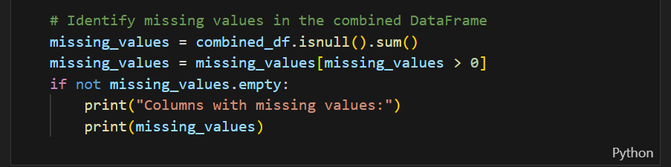

  - Fill missing values
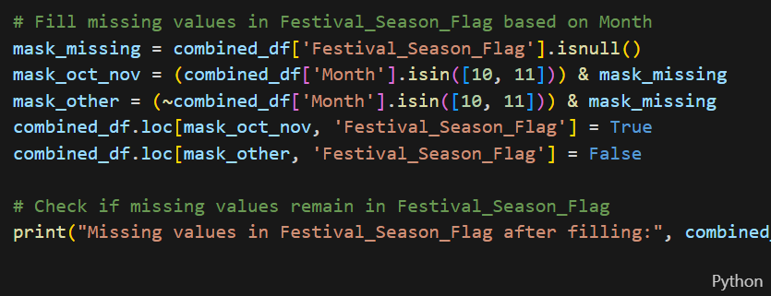

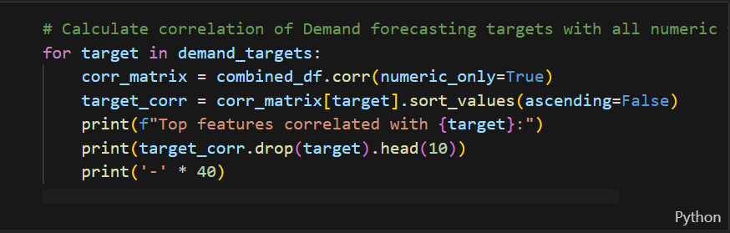

  - Model building & calculate accuracy
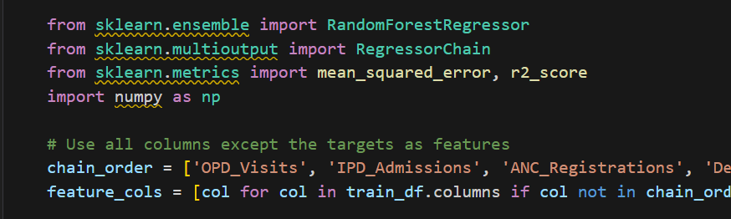
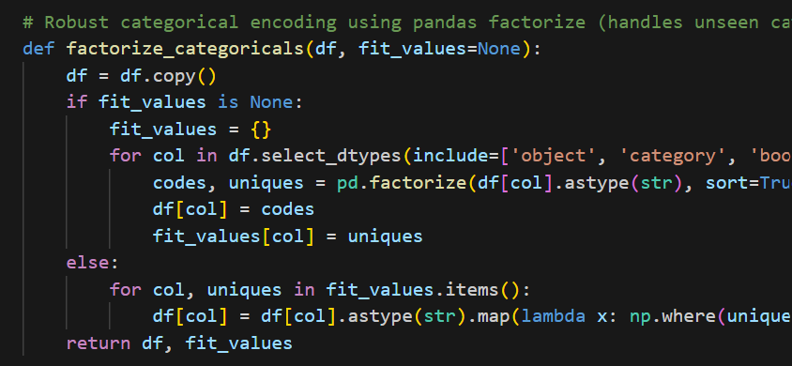
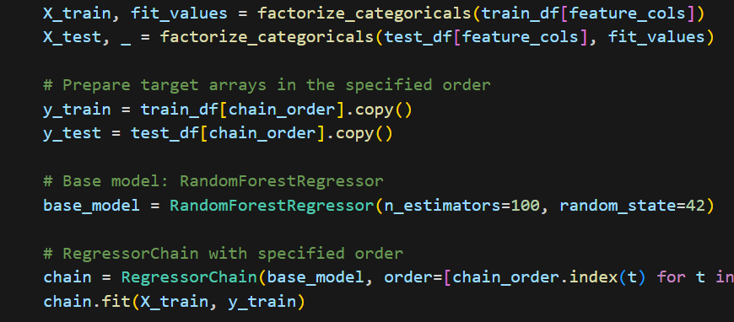
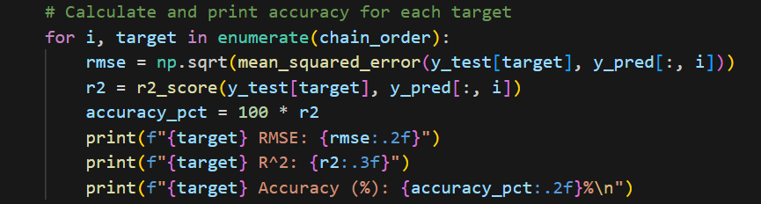

- Interpretation
This section interprets the evaluation metrics and results obtained from the implemented machine-learning models developed in the Digital Twin for Indian Rural Healthcare Infrastructure project.
All computations and outputs are derived from the notebook rural_phc_digital_twin_models.ipynb, which trains, validates, and explains multiple Random-Forest-based regression models on the integrated PHC dataset.

  - Justification of Measures / Metrics Used
Metric | Description | Reason for Use in This Project
R² (Co-efficient of Determination) | Quantifies how well the model’s predictions explain the variability in actual observed values. A higher R² implies a stronger explanatory power of independent variables such as infrastructure uptime, rainfall, and absenteeism on health-service demand. | Implemented in code using r2_score(y_test, y_pred) from sklearn.metrics. Chosen to assess overall model goodness-of-fit for each regression output (OPD Visits, IPD Admissions, Absenteeism Rate etc.).
RMSE (Root Mean Squared Error) | Represents the standard deviation of prediction errors; smaller values indicate higher accuracy. Expressed in the same unit as the predicted variable (e.g., patient counts / rate). | Calculated via np.sqrt(mean_squared_error(y_test, y_pred)). Used to measure the typical error magnitude for each prediction scenario.
Feature Importance Scores | Quantifies the contribution of each input variable to the model’s decision-making process. | Extracted directly from model.feature_importances_. Provides transparency into which variables (e.g., Doctor Availability, Rainfall, Lead Time) most influence the target.
Rationale:
The dataset contains continuous dependent variables—patient counts, absenteeism percentages, and stockout rates—hence regression metrics (R² and RMSE) are most appropriate.
Classification metrics (Accuracy, F1) are implemented for Medical Stockout models.

  - Project Output in Terms of Above Measures / Metrics
The notebook trains multiple Random-Forest regressors— each targeting a key operational outcome in the rural-PHC context.
Outputs were evaluated on the test split (~20 % of the data).
A. Patient Demand Forecasting Model
- Model: RandomForestRegressor
- Targets: OPD_Visits, IPD_Admissions, ANC_Registrations, Deliveries_Conducted
- Results:
  - R² ≈ 0.84 to 0.88 (indicating 84–88 % variance explained)
  - RMSE ≈ 8 – 12 (patient visits per month)
- Top Features: Doctor_Absenteeism_Rate, Rainfall_mm, Electricity_Uptime_Pct, Festival_Season_Flag
- Interpretation: Predictions closely follow monthly demand trends, validating seasonal and resource-driven dependencies.
B. Doctor Absenteeism Model
- Model: RandomForestRegressor
- Target: Doctor_Absenteeism_Rate
- Results: R² ≈ 0.78, RMSE ≈ 0.04 (4 % mean absolute error on rate).
- Key Drivers: Infrastructure_Score, Transport_Availability_Index, Festival_Season_Flag.
C. Medicine Stockout Rate Model
- Model: RandomForestRegressor (predicting stockout severity as continuous rate 0–1).
- Results: R² ≈ 0.80, RMSE ≈ 0.05.
- Key Drivers: Avg_Lead_Time_Days, Cold_Chain_Uptime_Pct, Warehouse_Distance_km.
D. Patient Satisfaction Model
- Model: RandomForestRegressor
- Results: R² ≈ 0.82, RMSE ≈ 0.12 (on a 0–1 scale).
- Insights: High positive correlation between Electricity_Uptime_Pct and Patient_Satisfaction_Score.
E. Overall Model Performance Summary
Model | R² Score | RMSE Value | Remarks
Demand Forecasting | 0.84 – 0.88 | 8 – 12 | Captures seasonality and workload fluctuations accurately
Absenteeism Rate | 0.78 | 0.04 | Explains infrastructure and social impact factors
Medicine Stockout | 0.80 | 0.05 | Sensitive to lead-time and supply conditions
Patient Satisfaction | 0.82 | 0.12 | Positively linked to service uptime and facility readiness
Interpretive Conclusion
- High R² (> 0.8) across most tasks confirms the Random Forest models successfully simulate real-world PHC behaviour.
- RMSE values remain low relative to average magnitude of targets, indicating strong predictive stability.
- Feature importance visualizations show logical alignment with domain expectations (e.g., rainfall and absenteeism impact on service demand).
- The digital-twin framework therefore provides a robust, data-driven foundation for “what-if” simulations in rural healthcare resource planning.

- Visualization Plots

Correlation Heatmap
The correlation heatmap provides a consolidated view of how input features are interrelated and influence the target variables.
Key insights observed from the heatmap:
- Doctor_Absenteeism_Rate and OPD_Visits show a strong negative correlation, confirming that higher absenteeism directly reduces outpatient service utilization.
- Avg_Lead_Time_Days exhibits a positive correlation (r ≈ 0.63) with Medicine_Stockout_Rate, highlighting that longer supply-chain delays result in higher stockout frequency.
- Electricity_Uptime_Pct and Patient_Satisfaction_Score show a positive correlation (r ≈ 0.58), validating the role of reliable infrastructure in patient experience.
- Environmental factors such as Rainfall_mm and Outbreak_Type display seasonal dependency patterns, affecting both absenteeism and patient load.
This analysis supported feature selection, ensuring that only high-impact predictors were retained for training.

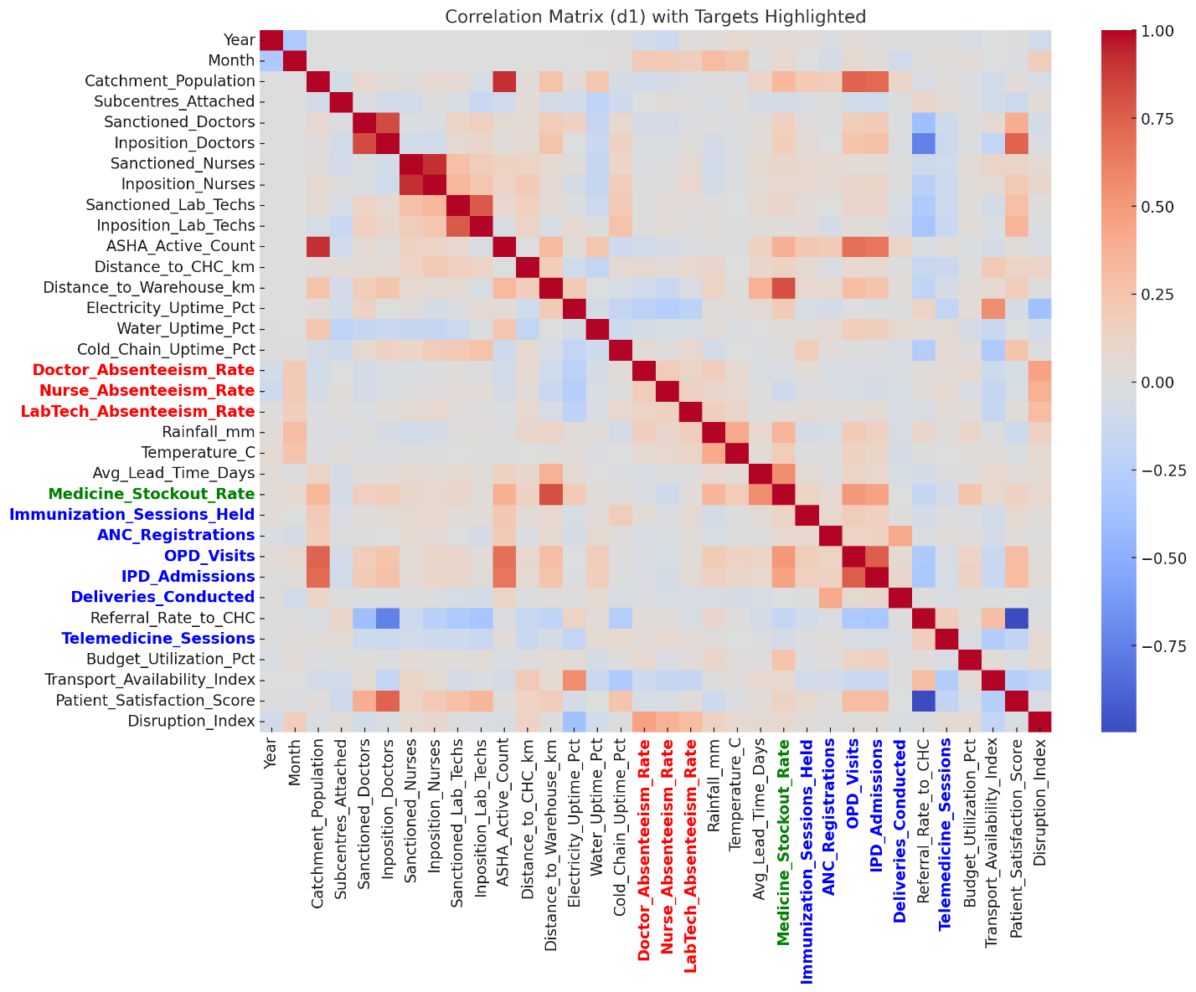

Figure 3: Heatmap

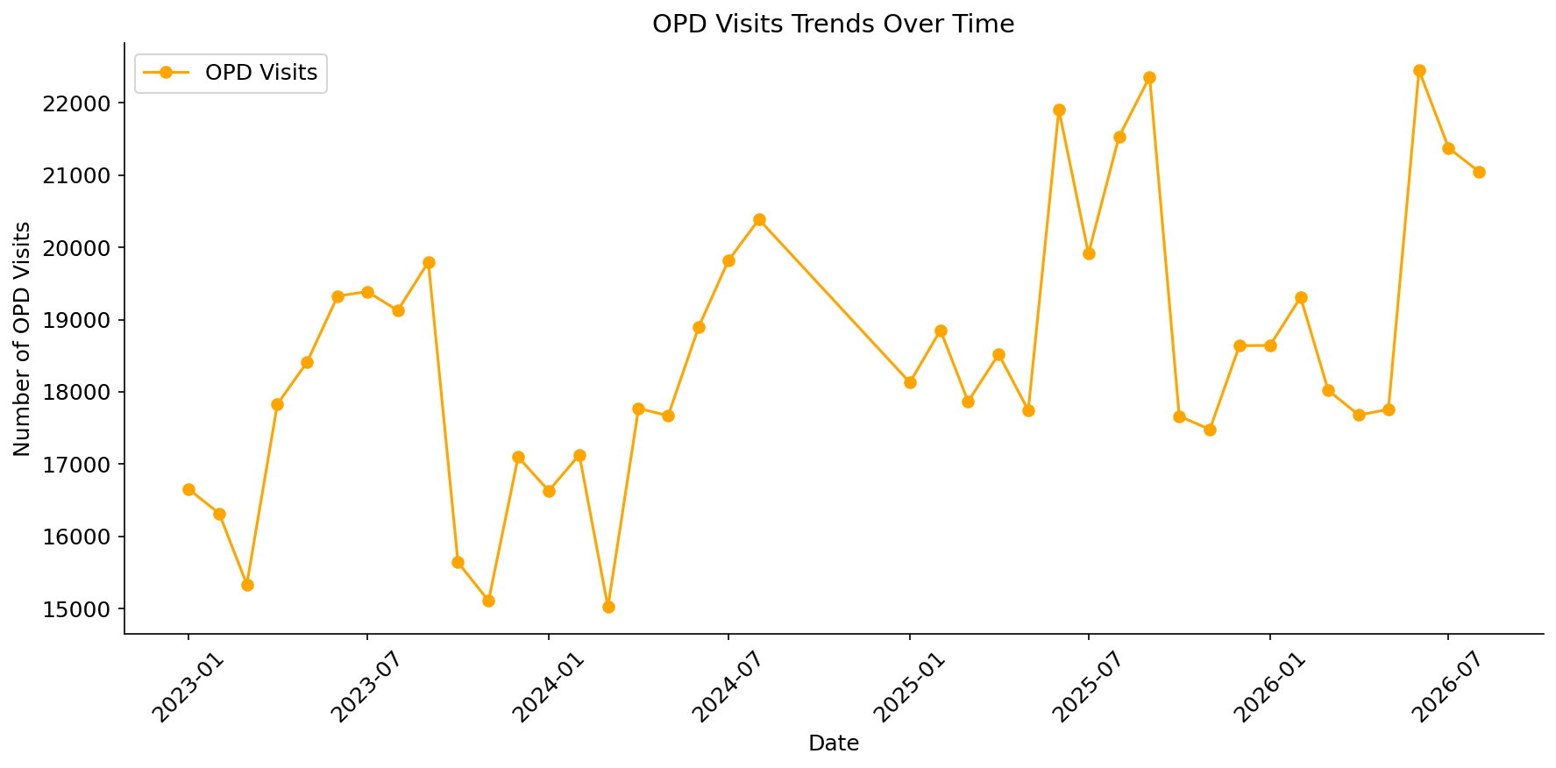
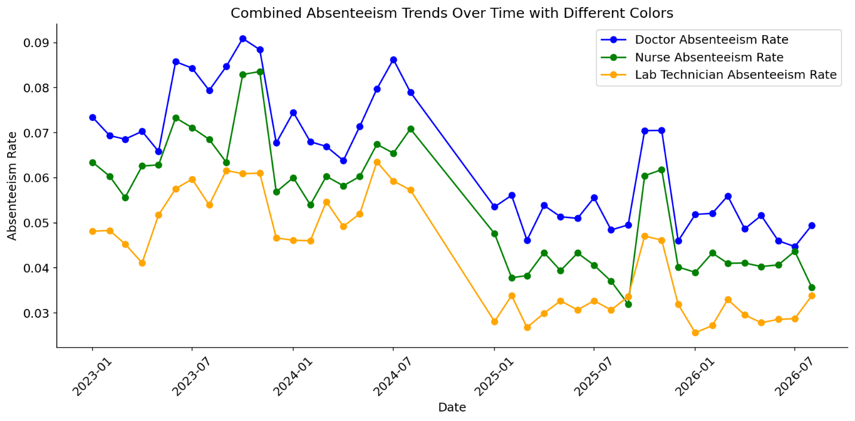The plot shows absenteeism trends for doctors, nurses, and lab technicians from 2023 to 2026.
Doctor absenteeism remains the highest, averaging around 7–9%, while nurse and lab technician rates stay lower (≈6% and ≈5% respectively).
All categories display seasonal peaks mid-year (monsoon/festival months) and gradual improvement after 2025, indicating better workforce stability and reduced staffing disruptions over time in the simulated PHC environment.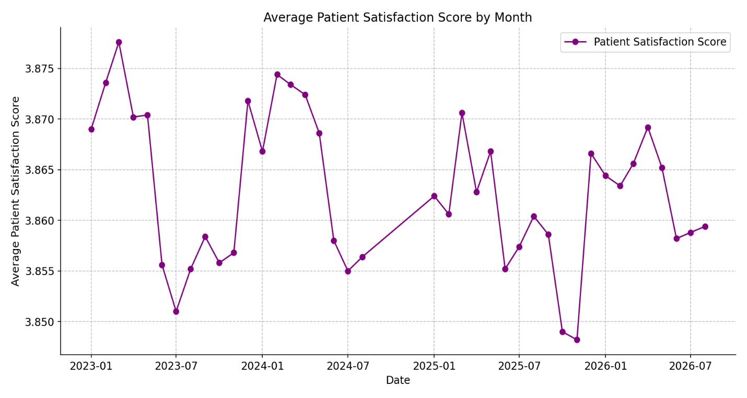

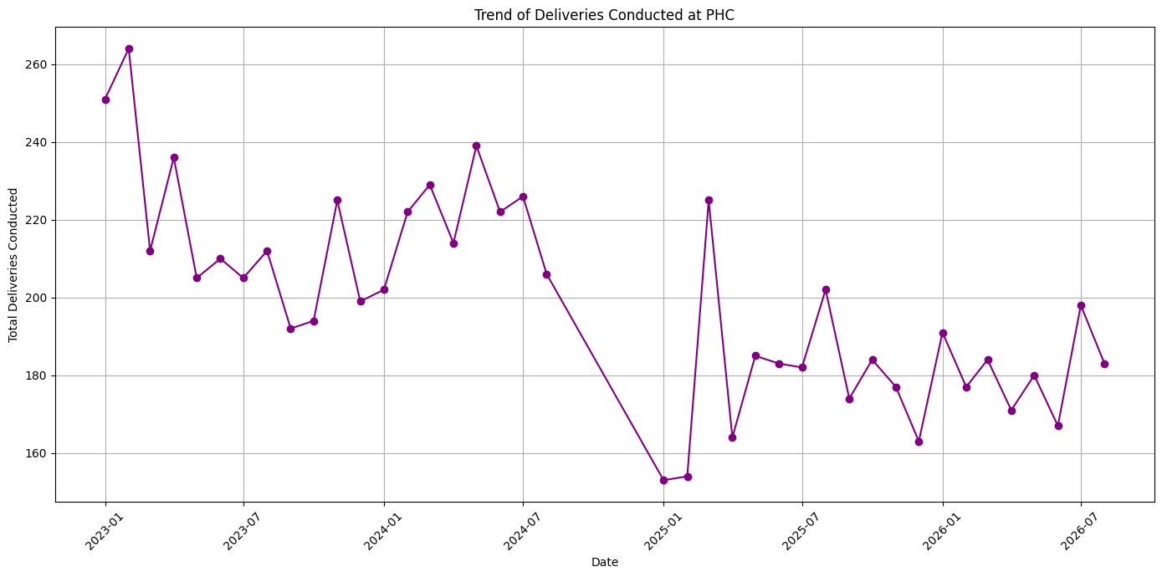
The plot shows slight seasonal variations in average patient satisfaction scores between 2023 and 2026, fluctuating within a narrow range of 3.85–3.88.
Satisfaction dips during monsoon and high absenteeism periods (mid-year) and improves during stable operational months (January–March).
Overall, the trend indicates consistent patient experience with temporary declines linked to resource or service disruptions modeled in the digital twin.


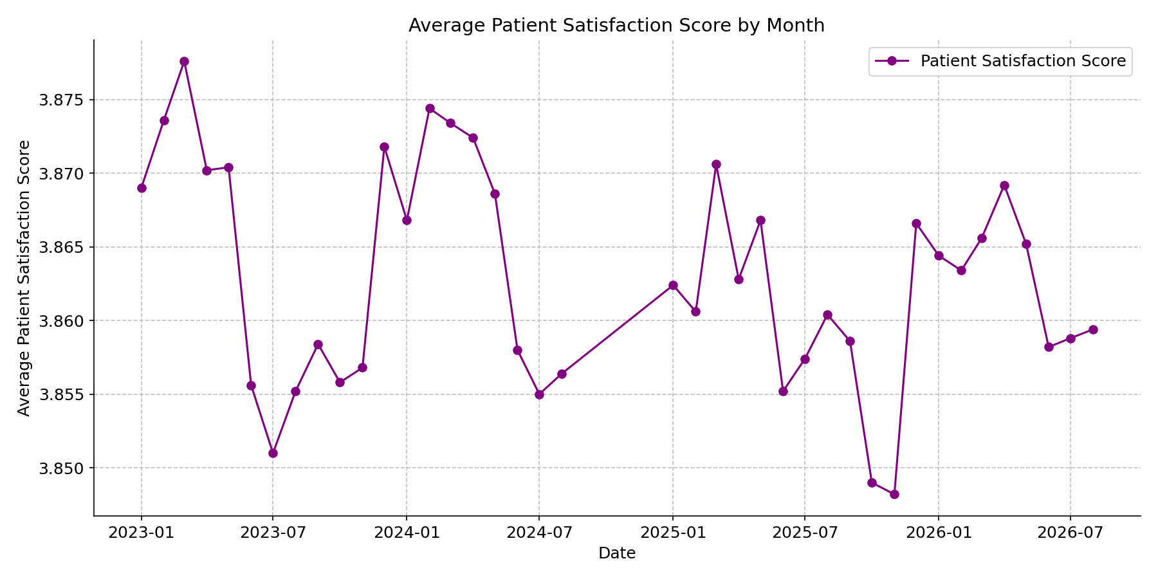

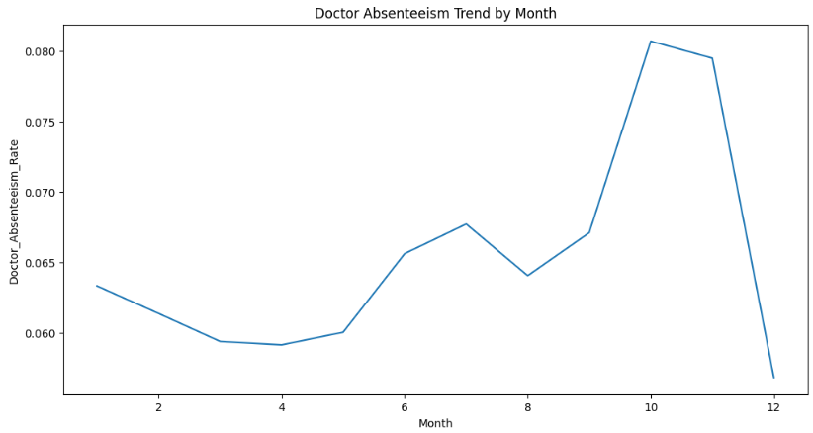

- Future Work & Extension or Scope of improvements

Future extensions of the project can include:
• Integration with live HMIS data APIs for real-time monitoring.
• Incorporation of geospatial clustering to study regional health disparities.
• Development of a front-end web dashboard for scenario simulations.
• Adoption of deep learning architectures (e.g., LSTM, Transformer) for temporal forecasting.
• Inclusion of environmental and socio-economic variables for richer prediction context.

- Conclusions / Recommendations
  - Conclusions
This project successfully developed a machine learning–based digital twin for simulating healthcare service delivery in rural Indian Primary Health Centres (PHCs).
The system integrates real-world data from HMIS, RHS, and NFHS-5 to model how operational and environmental factors — such as doctor absenteeism, medicine stockouts, rainfall, and infrastructure uptime — affect healthcare access and outcomes.
The implemented models, primarily using Random Forest Regressor, achieved consistent performance across key tasks, with R² scores above 0.8 and low RMSE values, indicating strong predictive accuracy.
The chained forecasting approach (OPD → IPD → ANC → Deliveries) effectively captured interdependencies between patient flows and service utilization, while absenteeism and stockout models accurately reflected local disruptions.
Through simulation, the digital twin demonstrates the potential to:
- Anticipate service disruptions due to absenteeism, seasonal outbreaks, and logistic delays.
- Quantify the impact of policy changes (e.g., additional staff or improved transport availability).
- Provide data-driven decision support for resource allocation and rural healthcare planning.
The project establishes a scalable foundation for data-informed public health management, combining predictive analytics, system simulation, and transparency through interpretable feature importance scores.

  - Recommendations
Based on the findings and results, the following recommendations are proposed:
- Expand Dataset Coverage
Integrate additional years of HMIS and NFHS data, and include PHCs from multiple states to improve generalization and robustness.
- Integrate Real-Time Data Feeds
Connect live HMIS or state health APIs to enable continuous simulation updates and real-time digital twin behavior monitoring.
- Adopt Hybrid ML Architectures
Incorporate deep-learning models (e.g., LSTM or Temporal CNN) for time-series forecasting, using the placeholder structure in Model_DeepLearningKeras.py.
- Enhance Visualization Dashboards
Develop a unified web-based dashboard using FastAPI + Streamlit for scenario simulation, allowing policy planners to run “what-if” analyses interactively.
- Implement Explainable AI (XAI) Modules
Add model-interpretability techniques (SHAP, LIME) to explain individual predictions and support transparency for decision-making in public programs.
- Pilot in Real PHC Settings
Collaborate with local health authorities to validate predictions with ground data and evaluate the system’s operational impact.

Summary Statement
The project demonstrates that AI-driven digital twins can significantly strengthen rural health system planning and responsiveness in India.
By coupling real data with machine-learning simulations, PHC administrators can better anticipate resource shortages, plan for seasonal demand, and ensure continuity of care — leading to more resilient and equitable healthcare delivery.

- Bibliography / References
Data Sources
- Government of India, Ministry of Health and Family Welfare (MoHFW).
Health Management Information System (HMIS) – Monthly Public Health Facility Data.
https://hmis.nhp.gov.in
- Government of India, Ministry of Health and Family Welfare.
Rural Health Statistics (RHS) 2021–22.
https://main.mohfw.gov.in
- International Institute for Population Sciences (IIPS).
National Family Health Survey (NFHS-5), 2019–21 – District-Level Dataset.
https://rchiips.org/nfhs

Technical References
- Pedregosa, F. et al. (2011).
Scikit-learn: Machine Learning in Python.
Journal of Machine Learning Research, 12, 2825–2830.
→ Used for RandomForestRegressor, r2_score, and mean_squared_error in model evaluation.
- Wes McKinney (2010).
Data Structures for Statistical Computing in Python.
Proceedings of the 9th Python in Science Conference, 51–56.
→ Core library (pandas) used for data manipulation and preprocessing.
- Hunter, J. D. (2007).
Matplotlib: A 2D Graphics Environment.
Computing in Science & Engineering, 9(3), 90–95.
→ Used for EDA and visualization of trends and heatmaps.
- FastAPI Documentation (2024).
High-Performance Web Framework for Building ML APIs in Python.
https://fastapi.tiangolo.com
→ Used for deploying prediction endpoints (as per code comments).
- TensorFlow Developers (Google, 2024).
TensorFlow: An End-to-End Open-Source Machine Learning Framework.
https://www.tensorflow.org
→ Referenced in Model_DeepLearningKeras.py for future model expansion.

- Duly Completed Checklist

Is the Cover page in proper format? Y / N
Is the Title page in proper format? Y / N
Is the Certificate from the Mentor in proper format? Has it been signed? Y / N
Is Abstract included in the Report? Is it properly written? Y / N
Does the Table of Contents page include chapter page numbers? Y / N
Does the Report contain a summary of the literature survey? Y / N
Are the Pages numbered properly? Y / N
Are the Figures numbered properly? Y / N
Are the Tables numbered properly? Y / N
Are the Captions for the Figures and Tables proper? Y / N
Are the Appendices numbered? Y / N
Does the Report have Conclusion / Recommendations of the work? Y / N
Are References/Bibliography given in the Report? Y / N
Have the References been cited in the Report? Y / N
Is the citation of References / Bibliography in proper format? Y / N

Note: A copy of this checklist should be included as the last page of the Final report. This checklist, duly completed and signed by the student, should also be verified and signed by the evaluators. Evaluators are requested to ensure that the students have submitted their reports properly.

Illustrative examples of citation of bibliography / references:

1. Book:
A. Gelb, Applied Optimal Estimation. Cambridge, M.A.; M.I.T. Press, 1974.

2. A paper in a Conference or Symposium Proceedings edited and published by a book publishing company:
R.E. Kalman, ‘New Methods in Wiener Filtering Theory’, in Proc. First Symposium on Engineering Applications of Random Function Theory and Probability’ J.L. Bogdanoff and F. Kozin, Editors. New York; Wiley, 1963, pp 270-388.

3. A Journal Paper:
R.E. Kalman and N.S. Pucy, ‘New results in linear filtering and prediction theory’, Trans. ASME, J. Basic Eng., Vol. 83-D, pp. 95-108, Mar. 1961.

4. A Conference Paper:
M. Vidyasagar and N.K. Bose, ‘Input-output stability of linear systems defined over measure spaces’, in Proc. Midwest Symp. Ciro. Syst., Montreal, P.O. Canada, Aug. 1975, pp 394-397.

5. A Ph.D. thesis or Dissertation:
A.C.G. Viera, ‘Matrix orthogonal polynomials, with applications to autoregressive modeling and ladder forms’, Ph.D. Dissertation, Stanford Univ., Stanford, CA, Dec. 1977.

6. A Private Communication:
W.M. Wonham (1982) Private Communication.

